**DFT 50114 INTEGRATED PROJECT**

**PROPOSAL PROJECT**

|  |  |
| --- | --- |
| **NAME** | **NO. MATRIX** |
| MUHAMMAD NURNAJMI BIN KHAIRUL NAZRI | 10DDT22F1024 |
| MOHAMAD AZHAN BIN MOHD. FIRDAUS | 10DDT22F1009 |
| MUHAMMAD ZUNNUR WAFIY BIN ZAIRUL FUAAD | 10DDT22F1012 |

Food Ordering System

**TITLE**

KHOLILAH BINTI HILALUDDIN

**PROJECT SUPERVISOR**

**Table of Content**

Title 1

Table of Content 2

1. Introduction 3
2. Problem Statement 3
3. Objective 4
4. Scope 4
5. Project Significant 5
6. Literature Review 6
7. Methodology 7
8. References 8
9. Gant Chart 9
10. Cost Planning 10
11. Conclusion 10
12. **INTRODUCTION**

In the digital age, the way people order food has dramatically transformed. Traditional methods of placing orders over the phone or visiting a restaurant have given way to online food ordering systems. These systems offer convenience, efficiency, and a broader range of choices, making them increasingly popular among consumers. This project focuses on developing an innovative and user-friendly food ordering system that streamlines the process for both customers and restaurant operators.

1. **PROBLEM STATEMENT**

The existing food ordering methods, such as phone orders or in-person orders, have several drawbacks. They often lead to miscommunication, long waiting times, and inefficiencies in order processing and delivery. Moreover, these methods do not provide customers with real-time updates on their orders or enable them to browse through a comprehensive menu with detailed descriptions and prices. For restaurants, managing orders manually can be cumbersome and error-prone, leading to customer dissatisfaction and potential loss of business. There is a need for a robust, efficient, and reliable food ordering system that addresses these issues and enhances the overall customer experience.

1. **OBJECTIVES**
2. Enhance Order Accuracy: Reduce errors in order processing by automating the order management system.

1. Improve Efficiency for Restaurants: Provide restaurant operators with a comprehensive dashboard to manage orders, inventory, and customer interactions effectively.
2. Ensure Secure Transactions: Implement secure payment gateways to protect customer data and financial transactions.

1. **SCOPE**

The scope of this project encompasses the following components:

1. User Interface Design: Development of a web and mobile application interface for customers to browse menus, place orders, and make payments.

1. Order Management System: Creation of a backend system for restaurants to receive, process, and manage orders efficiently.

1. Payment Integration: Incorporation of secure payment gateways to handle transactions.

1. Database Management: Implementation of a database to store customer information, order history, menu details, and restaurant data.

1. Scalability and Flexibility: Ensuring the system can be easily scaled and adapted to accommodate multiple restaurants and a growing number of users.

**5.0 PROJECT SIGNIFICANCE**

The significance of the Online Food Ordering System is multifaceted:

For Customers:

* Convenience: Allows customers to place orders from anywhere at any time.
* Time-Saving: Reduces the need for phone calls or physical visits to restaurants.
* Transparency: Provides clear menus, prices, and order tracking.

For Restaurants:

* Efficiency: Streamlines order management and reduces human errors.
* Increased Reach: Expands customer base beyond the local area.
* Data Insights: Offers valuable data on customer preferences and peak ordering times.

For Society:

* Modernization: Contributes to the digital transformation of traditional businesses.
* Job Opportunities: Creates new roles in tech support and system management.

**6.0 LITERATURE REVIEW**

1. Online Food Ordering Systems: An Overview

Online food ordering systems have become increasingly popular, leveraging the internet to facilitate the ordering process. Studies have shown that such systems enhance customer satisfaction and operational efficiency.

2. Technological Foundations

PHP and MySQL: PHP is a widely-used open-source scripting language suited for web development, while MySQL is a powerful database management system. Together, they form a robust framework for building dynamic web applications.

3. User Experience (UX) and User Interface (UI) Design

Effective UX/UI design is crucial for the success of online food ordering systems. Research indicates that user-friendly interfaces and seamless navigation significantly improve user engagement and satisfaction.

4. Impact on the Food Industry

The implementation of online ordering systems has revolutionized the food industry, enabling restaurants to manage orders more efficiently, reduce wait times, and increase sales. Various case studies highlight significant improvements in operational workflows and customer service.

**7.0 METHODOLOGY**

System Analysis and Design

• Conduct requirements gathering through surveys and interviews with potential users (both customers and restaurant staff).

• Create use case diagrams and flowcharts to visualize system processes.

Development Tools

• Frontend: HTML, CSS, JavaScript for the user interface.

• Backend: PHP for server-side scripting.

• Database: MySQL for data storage and management.

Implementation Steps

Phase 1: Design database schema and develop backend functionalities such as user authentication, order management, and payment processing.

Phase 2: Develop frontend interfaces, ensuring responsive design for various devices.

Phase 3: Integrate backend and frontend components and conduct unit testing.

Testing and Validation

• Perform extensive testing, including functional testing, usability testing, and performance testing.

• Gather feedback from a pilot group of users and refine the system based on their input.

Deployment and Maintenance

• Deploy the system on a live server.

• Provide user training and support.

• Plan for regular maintenance and updates based on user feedback and technological advancements.

**8.0 REFERENCES**

ProjectManager.com. (n.d.). Gantt chart examples for project planning. Retrieved May 18, 2024, from https://www.projectmanager.com/guides/gantt-chart#:~:text=This%20Gantt%20chart%20example%20shows,chart%20for%20planning%20a%20project

ScienceGate. (2021). Challenges faced by traditional offline restaurants. *International Journal for Research in Applied Science and Engineering Technology (IJRASET), 8*(36),_ 10319-10322. <https://www.sciencegate.app/document/10.22214/ijraset.2021.36835>

Gursoy, D., & Chi, C. G. (2021). Hospitality management during the pandemic. *International Journal of Contemporary Hospitality Management, 33*(10)_, 3636-3655. <https://doi.org/10.1108/IJCHM-10-2021-1273>

Digital Society. (2021, July 14). Challenges and opportunities that traditional offline restaurants face. *Medium*. <https://medium.com/digital-society/challenges-and-opportunities-that-traditional-offline-restaurants-face-614836d0eb12>

YouTube. (n.d.). Gantt chart tutorials [Playlist]. Retrieved May 18, 2024, from <https://youtube.com/playlist?list=PLBLPjjQlnVXXBheMQrkv3UROskC0K1ctW>

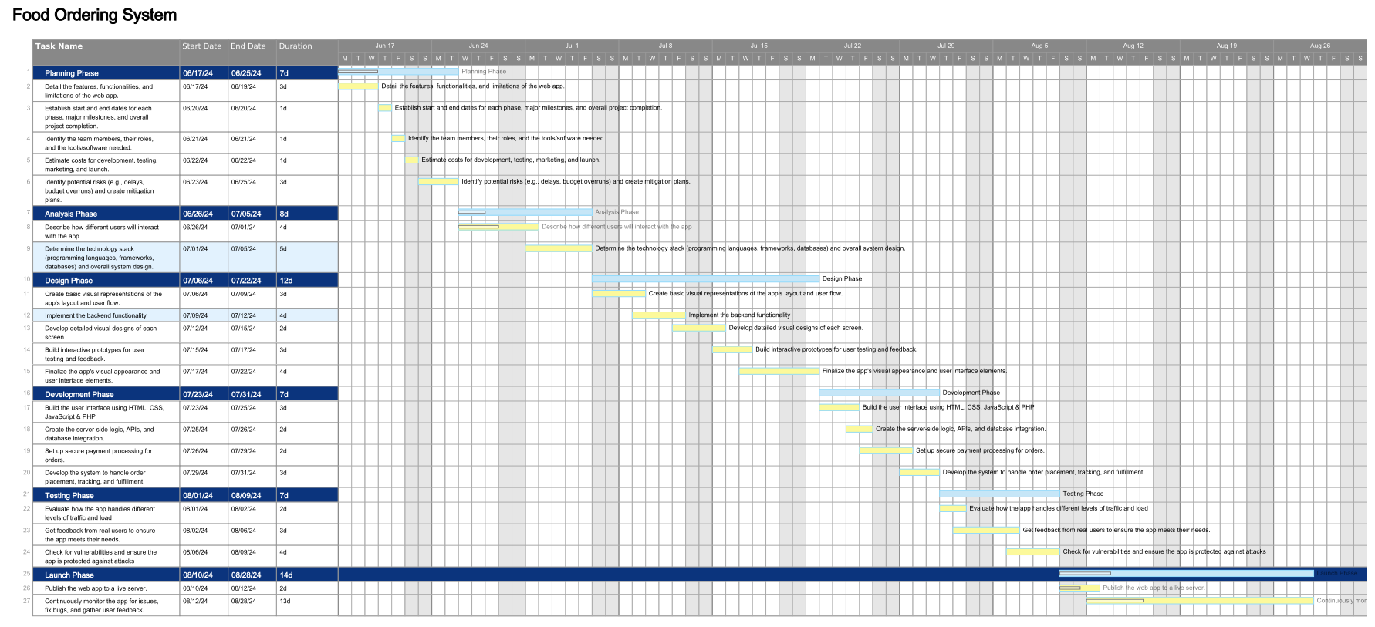 **9.0 Gantt Chart**

|  |
| --- |
|  |
|  |  |

**10.0 Cost Planning**

For this project we had no any spend cost as we are utilizing a free website for domain and hosting. The choosen payment gateway we have chosen is also free, except for a user transaction fee of 1.5% + RM1.50 per transaction.

|  |  |  |  |
| --- | --- | --- | --- |
| QTY | DESCRIPTION | PRICE (RM) | AMOUNT (RM) |
| 1  1 | Domain and Hosting (000WebHost)  Payment Gateway (Billplz) | 00.00  00.00 | 00.00  00.00 |
|  |  | TOTAL: | 0.00 |

Other costs needed for the report:

|  |  |
| --- | --- |
| Application | |
| Item | RM |
| Software and Tools: | freeware |
| Printing | 30.00 |
| TOTAL: | 30.00 |

**11.0 Conclusion**

In conclusion, the development of your food ordering web app represents a strategic move towards a more efficient and profitable business model. By leveraging free resources for domain, hosting, and payment gateway services, we've significantly reduced the financial barriers to entry, allowing you to quickly launch and establish your online presence. This cost-effective approach not only minimizes financial risk but also enables us to prioritize the delivery of a high-quality, user-friendly app tailored to your specific needs.

With this app, you'll be able to enhance the customer experience, expand your reach beyond your physical location, and streamline your operations, ultimately driving increased sales and revenue. We are confident that this web app will be a valuable asset to your business, contributing to brand awareness, customer loyalty, and a competitive advantage in the market. We look forward to your continued success as you embark on this exciting journey of digital transformation.